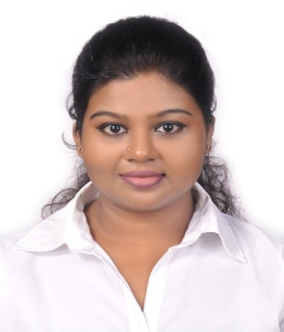**Gammanpila Arachchige Gimhani Rangana**

**No. 130, Kottawa Road, Mavitthara, Piliyandala.**

**Contact: 072 9926252 / 0112608220**

**Email: [gag.rangana1112@gmail.com](mailto:gag.rangana1112@gmail.com)**

OBJECTIVEBAL

To be a part of professionally managed organization with a scope for challenging and innovative career opportunity for learning, excellence and continuous improvement coupled with growth and individual development.

**PERSONAL DETAILS**

* Name in Full : Gammanpila Arachchige Gimhani Rangana
* Name with initials : G.A.G Rangana
* Date of Birth : 22 December 1990
* Nationality : Sri Lankan
* Religion : Buddhist
* Civil Status : Single
* National ID No. : 908572130V
* Gender : Female

**EDUCATION QUALIFICATIONS**

**University:** Mangalore University – India 2011-2014 BA Degree complete in Combination of English Optional, Journalism, Psychology with 2nd upper class

**School Attended:** President Collage – Homagama

**Passed G.C.E. (Advanced Level Art – 2010)**

**Subject Pass**

Political Science S

Logic S

Sinhala S

**Passed G.C.E Ordinary Level 2007 )**

**Subject Pass**

Buddhism B

Sinhala B

Mathematics S

English C

Social Study S

Science S

Music C

Developmental Studies C

Competencies

* Computer Skill

Operating Systems: Microsoft, MS word, MS Excel

**Other Qualifications**

* 10 Days Internal ship in Independent Chanel in Sri Lanka.
* New Delhi TV (N.D.TV) Work shop
* School prefect board (2005-2010)
* President of School Health Association
* All Island Group Dance Competition (Kandyan) 1st place
* School House Captain in (2009 – 2010)
* School Championship under 19 & 21 in Shot put, Discus Throw and Javelin.

LANGUAGES KNOW

Sinhala, English

Fluent in speaking; Hindi. REFEREES :

1. Mrs.A.R.D.Rathnawathi

Teacher, AnandaBalikaVidyalaya, Colombo 10

57/A,”Arunu” Walauwatta, Malwana.

Tel : 0112535819

2. Mrs. W.M.R. Kosgahakumbura

Customer Care Service Manager

Bank of Ceylon – Maharagama.

Tel: 077744482/0112850779

I hereby confirm that the information given above are true and correct to the best of my knowledge.

………………………. ……………………..

Date Signature